Customer Behavior Analysis Report:
Project Overview:
The Project analyze Customer Shopping Behavior using transactional data from purchases across various product categories.
The goal is to uncover insights into spending patterns, subscription behavior, product preferences, customer segment behavior to guide strategic business decisions.

Dataset Info:
- Rows: 3900
- Columns: 18
- Customer Details: Age, gender, location, subscription status
- Purchase details: Item Purchased, Category, Amount, Season, size, color
- Shopping details: Discount, Previous purchase, Frequency purchase, Review rating,
Shipping type.
(Missing Data 37 in Review Rating)

Exploratory Data Analysis using Python:
Begin with data explorations checking columns Data structure
- Data loading: Import data using Pandas
- Exploration: used df.info() and describe for statistical summary
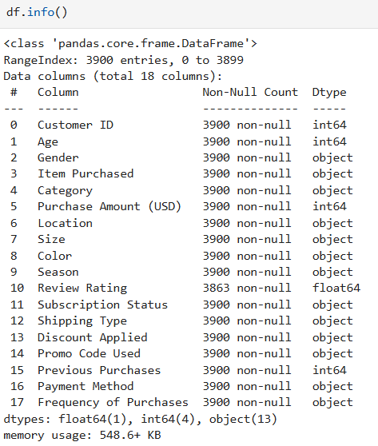
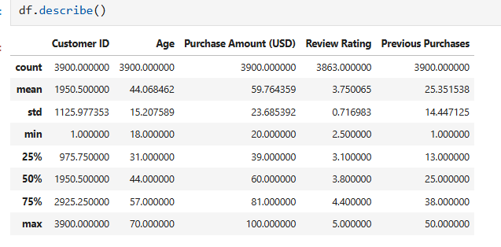
- Missing data handled: Check null values and imputed missing value in Review Rating column using median
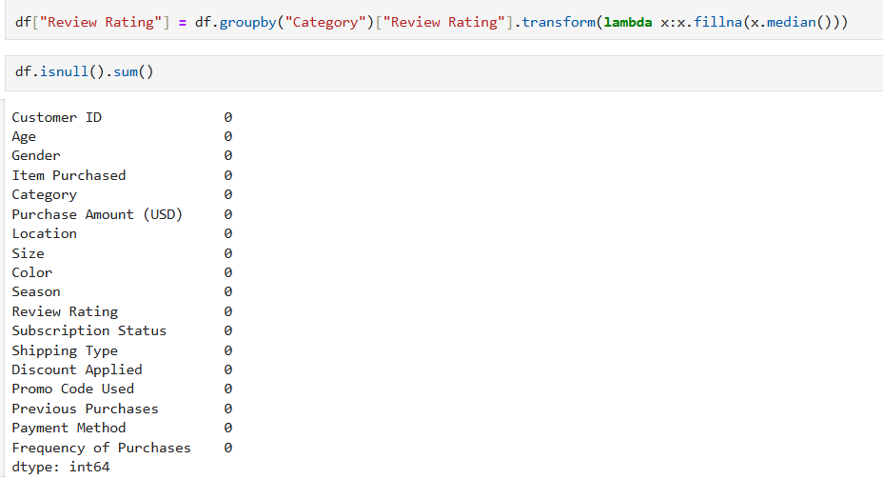
- Column standardization: Rename columns for better readability
- Featured Engineering: Created Age_Groups column from Ages,
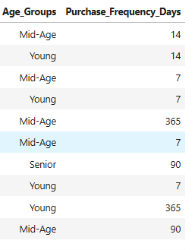
Created Purchase_Frequency_days column from purchase data
- Data consistency check: Verified Discount and Promocode are redundant dropped Promocode column

Data Analysis using SQL:
- Perform structured analysis in MS SQL Server to solved
Business Questions and Solutions

-- Q1. What are the total revenue generated by Male vs Female Customers:
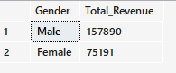
-- Q2. Which Customer used a discount but still spend more than average purchase amount :
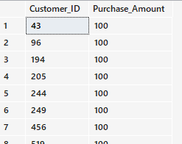
-- Q3. Which are the Top 5 Products with the highest Average Review Rating:
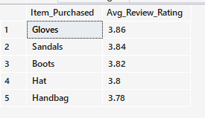
-- Q4. Compare the Average Purchase Amount between Standard and Express shipping:
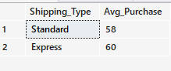
-- Q5. Do subscribed customers spend more ? Compare average spend and total revenue between Subscribers and Non-subscribers:
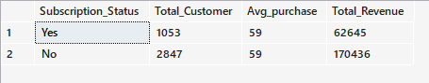
-- Q6. Which 5 Products have the highest percentage of purchase with Discount applied :
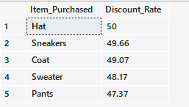
--Q7. Segment the Customers into New, Returning, Loyal based on their total number of Previous Purchase & show count of each segment :
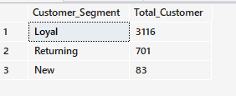
-- Q8. What are the Top 3 most Purchase Product within each Category :
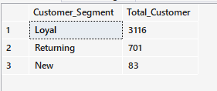
-- Q9. Are Customers who are repeat buyers (More than 5 Previous Purchases) also likely to subscribe:
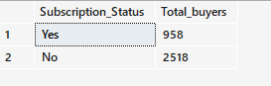
-- Q10. What is the Revenue Contribution of each Age Group:
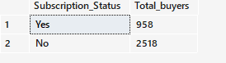

- Dashboard in Power BI:
Built an interactive dashboard in Power BI to present insights visually.
